**SP5 ADAS +DSM MDVR USER MANUAL**

**V1.02**

**Contents**

1、Product composition and Interface introduction.....................................................3

1.1 Product Composition 3

1.2 Product Interface 4

2、Installation 5

2.1 DSM Camera Installation 5

2.2 DVR Installation 6

2.3 ADADS Camera Installation 6

2.4 Whole stystem Installation Diagram 7

3、 Debuging 7

3.1 Debugging Preparation: Mobile APP connection 7

3.2 DSM Camera Debugging 9

3.3 ADAS Camera Debugging 10

3.4 Identification Debugging......................................................................................... 13

3.5 Safety Belt Debugging 14

4、FQA 15

5、Appendix 18

1、**Product composition and Interface introduction**

1.1 Product composition

ISP5 system include: Host device, DSM Camera, ADAS Camera

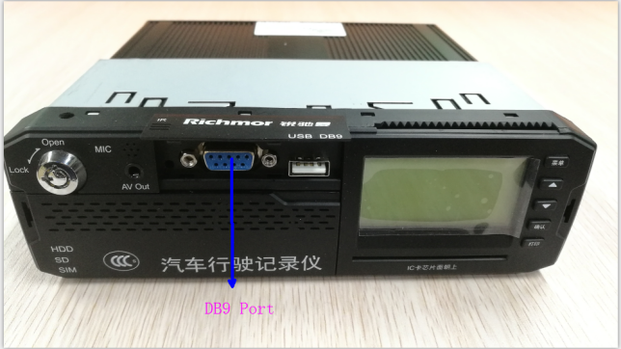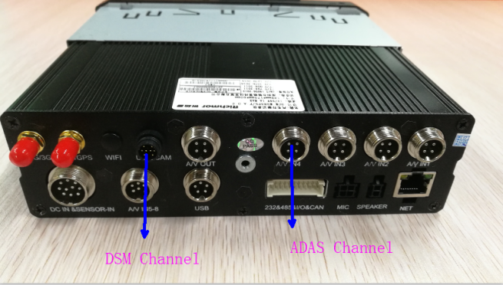

Photo 1.1—1**DVR Interface Ports**

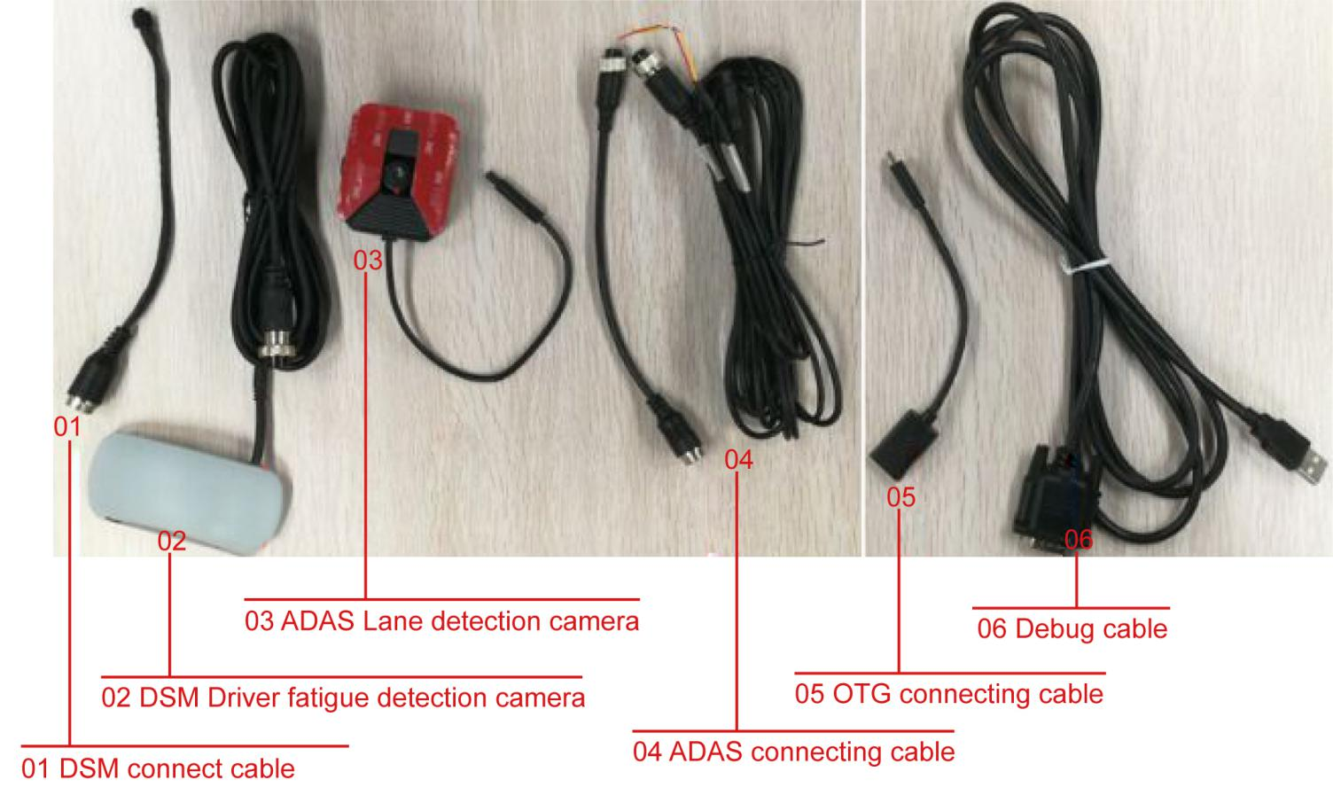

Figure1.1-2 Product Photo

1.2 Product Interface Instruction

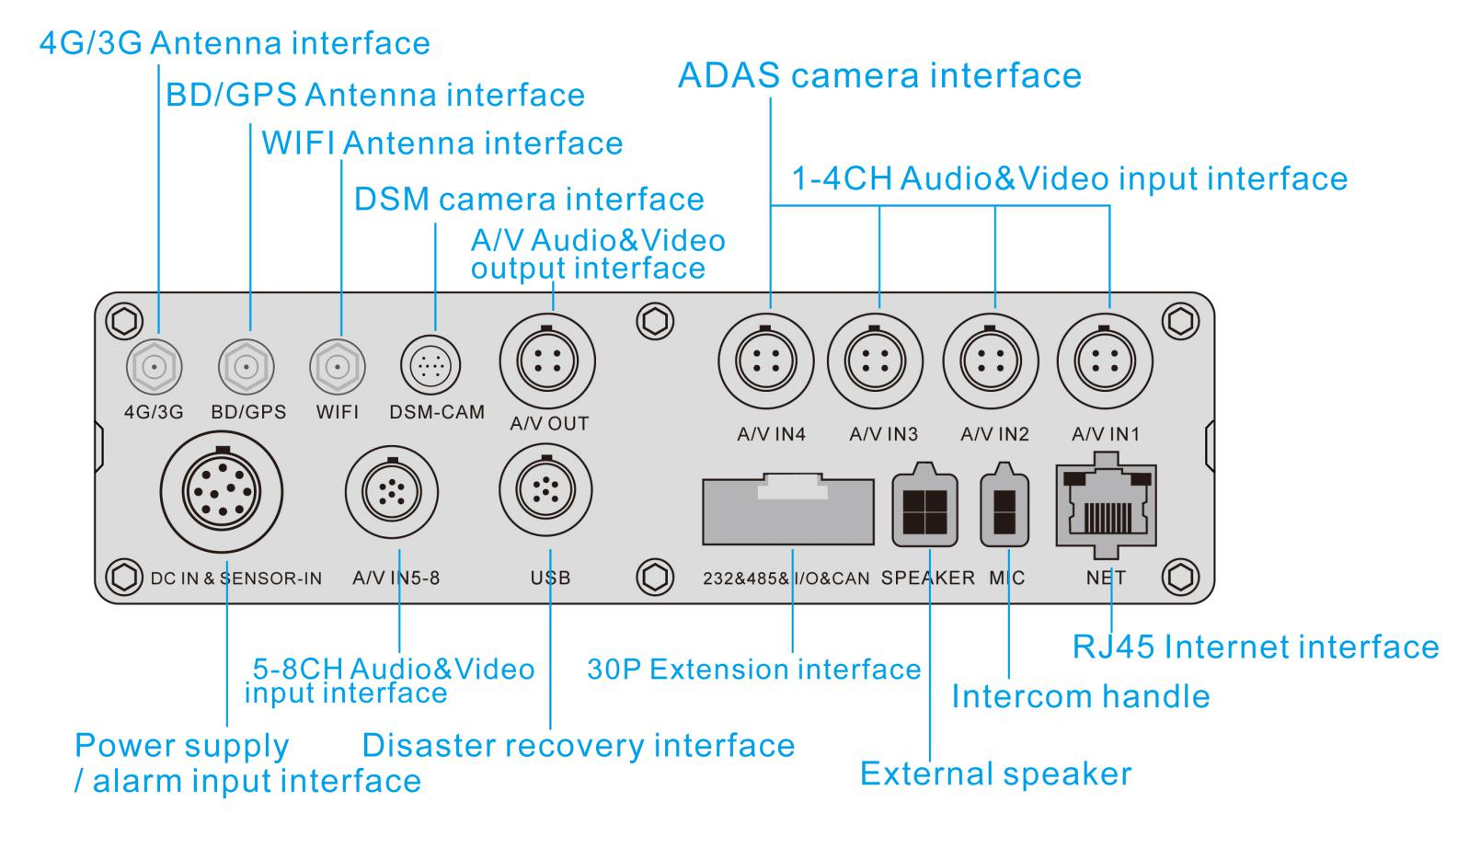

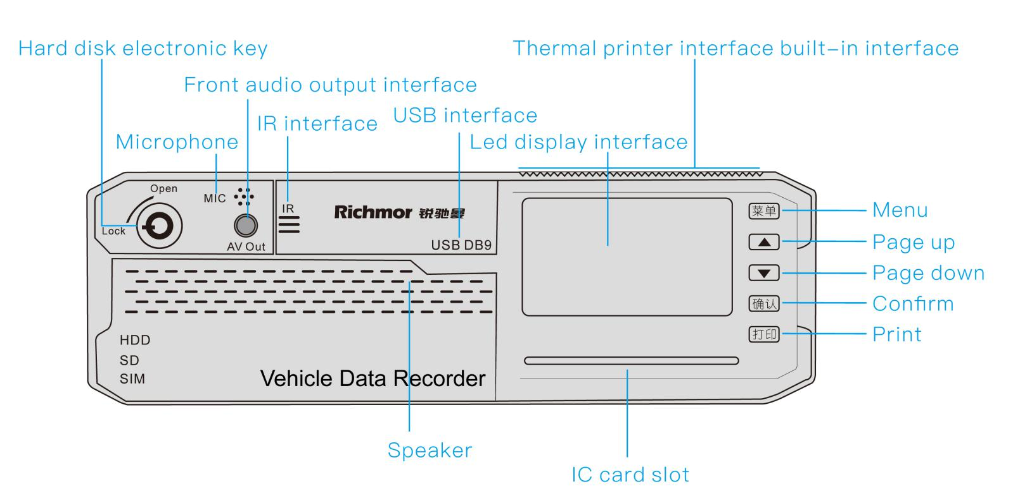

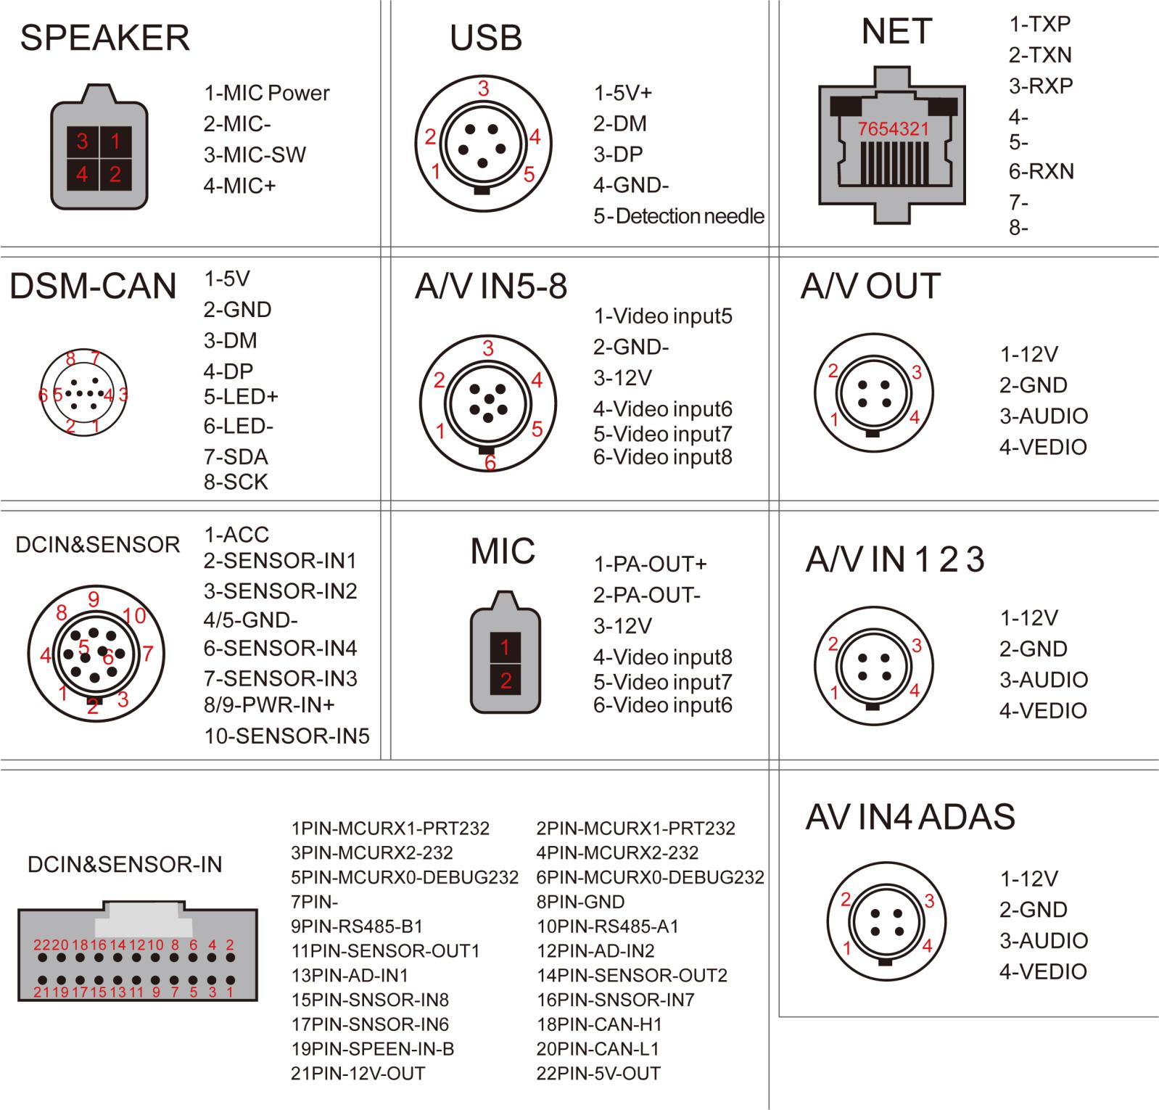

Figure1.2

2、Installation

2.1 DSM Camera Installation

Installation for Position and Angle, as Figure2.1-1:(Note: please take off the film from the camera before installation in case of image blurring.)

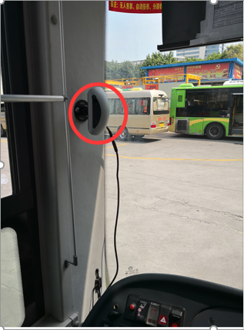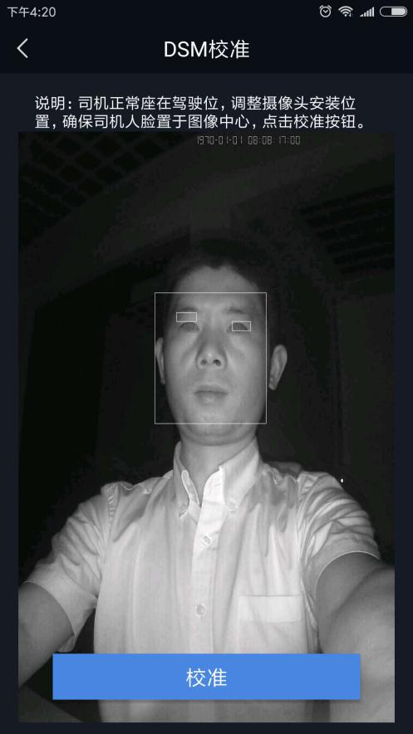

2.1—2 Figure 2.1-2

**Position: The right side of A Pillar**

Height: Within 10-15cm higher from Horizontal line of the driver’s eye.(Camera is better at a slightly tilted upward angle,with a slight elevation of the driver’s eye,which is better for fatigue detection)

Distance requirement: Within 70-100cm from Driver’s Head.

Installation method ：First, the universal joint base is drilled and fixed on the a-pillar, and the lens is fixed on the universal joint by screws. After adjusting the Angle to the mobile phone app, the lens is fixed with inner hexagon (the universal joint can be adjusted up and down, left and right, which is convenient for installation

Angle Requirement: Connect the mobile App, Configuration--- DSM Adjusting. Adjust the angle via APP video, The driver face in the middle of the video as Figure 2.1-2 above shows.

2.3 ADAS Camera Installation

Installation Position: With the center of the windshield, move up and down according to different vehicle types, it is installed a bit lower normally (Mind the Wiper Please! );

Method: Take off the file in the bottom of camera and stick on the right position of windshield directly.

Angle: Adjust the angle with moving the camera ( as 3.3 ADAS Debugging)

**2.3.1 ADAS Camera Installation notes**

ADAS Camera fixed in the center of windshield with 3M glue(Keep the position a bit upper of the center if a very sloping windshield vehicle; and a bit lower of the center if it is a vertical windshield)

The ADAS camera is an analog camera that does not support hot swapping. So it is requested connect the DVR first and then power-on DVR. If the camera connect any power port or cable power, then ADAS will not be able to work normally; and have to restart the DVR to restore.

1)Connect the turning signal cable to the vehicle. The turning signal cable is 3V-24V. The red line is for the left turn and the yellow line is for the right turn. (Red left, Yellow right)

2)Once the turn signal is connected, there will be a triggle alarm. Both High-Power and Low-Power are available for alarm connection depends on actual local condition and customer has different requests.

2.4 Installation Diagram

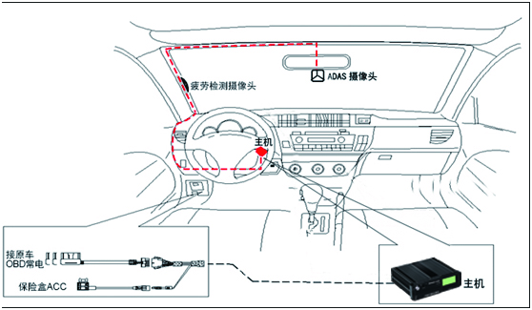

Figure 2.5

1. Debugging

3.1

1. Preparation: Install the APP and connect the DVR

App (Android) installation as below:

Install the APK App to the Android mobile Phone which should support OTG.

Download link:<https://www.pgyer.com/WT5k>

( Noted, OTG LINE and DATA LINE DO NOT REVERSED)

Power on the DVR (Connected DSM & ADAS cameras), then connect adjusting cable to DB9 port on DVR and one of OTG cable port, the other OTG port to mobile phone, as Figure3.1 below.

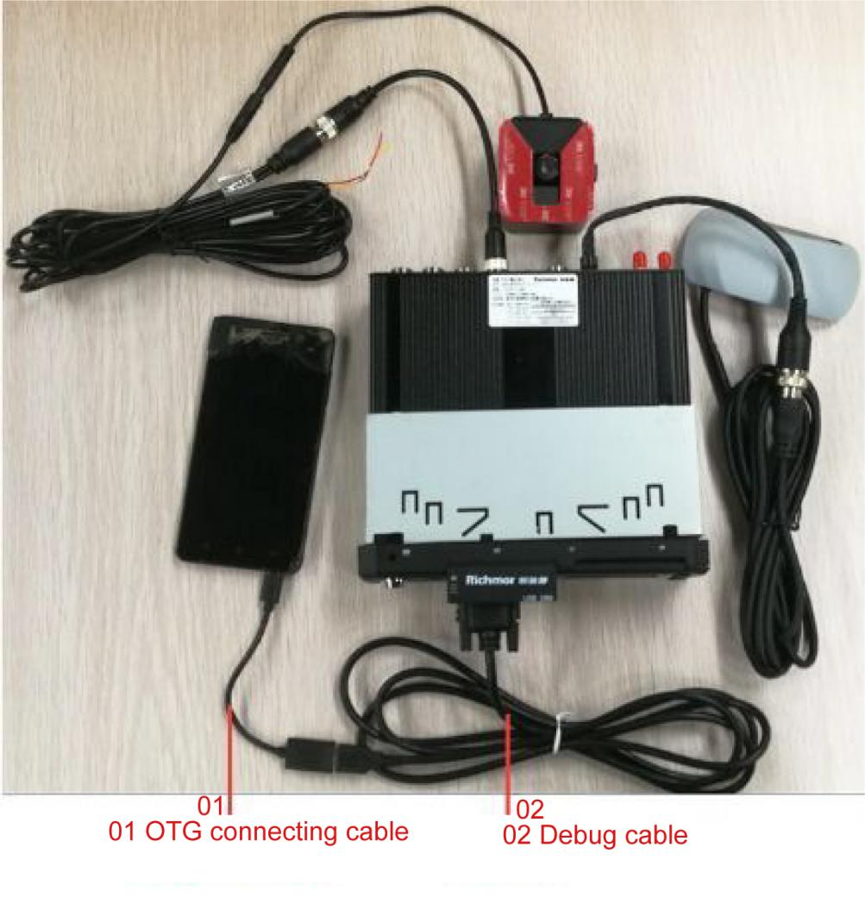

Figure3.1

MDVR Configuration

Host device -Alarm-ADAS alarm

Set up Capture, record to the correspondence channel 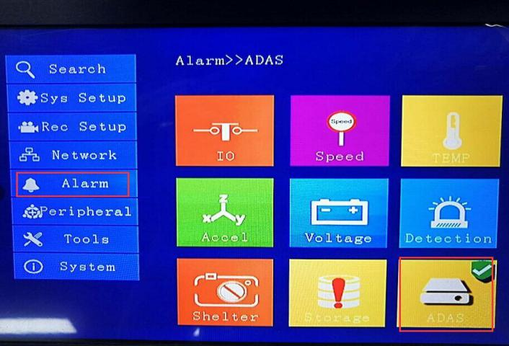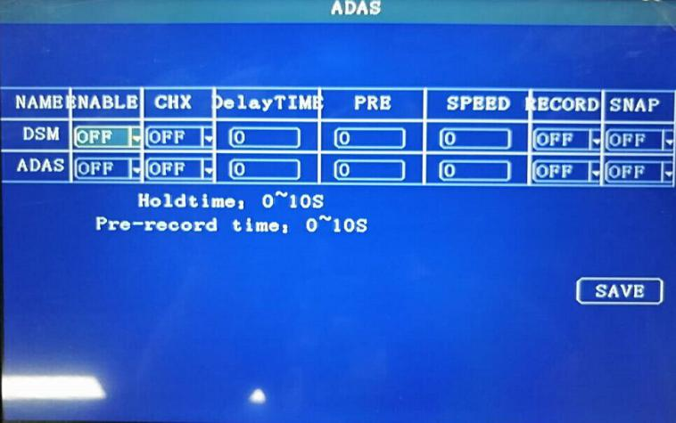

**Notes: The ADAS alarm video /photo from capture function must be uploaded to the device loaded with SD Card or HDD as memory. Or it will not recorded at all. (If only SD card is installed, the SD card must be set as the main video)**

3.2 DSM Camera Debugging

Open Adjustment APP, succeed working as Figure 3.2.1( Connect the OTG, the APP pop up normally, or need to open manually. ) , P.S. take off the film from the camera in case image blurring !

Description: The mobile app includes test mode and driving mode. Set to test mode during debugging

The setting access :"Configuration" - "Developer Options" - "Test Mode", click the button till become blue Figure 3.2.2 below

After the test is completed, turned off test mode, enter the driving mode.

Click “Configuration” - “DSM Calibration”, click “Open Video”, the video shows. Start to adjust the installation angle of camera according to the video. The driver is required to face the position of the driving posture in front of the entire screen normally, ensuring that the driver's face is placed at the center of the image. Click on the calibration and the anti-fatigue camera can be fixed after the calibration is successful. As shown in Figure 3.2.3 below:

3.3 ADAS Debug

ADAS it is an optional function of driving safety intelligent auxiliary system, including lane shift and collision warning.

**3.3.1 Alarm function declaration**：

|  |  |
| --- | --- |
| Vehicle turn left/right for deviate from present lane,not trigger turning light | Lane shift |
| With distance of Xm from front vehicle,X is related with speed,setting value data | Keep distance |
| With distance of Ym from front vehicle,Y is related with speed,setting value data | Collision danger |

**3.3.2 Debug instructions** ：

1. Refer to”2.3 ADAS camera install”statement,fix ADAS camera in the middle of windshield；
2. Measure the size of requested vehicle parameter,like following picture 3.3.2--1, record test result,then do APP configuration .

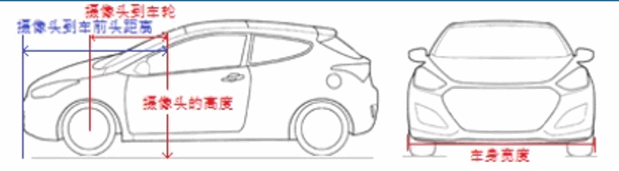

Figure 3.3.2—1

3）After fixing ADAS camera well, connect mobile phone APP,”configuration”---ADAS configuration”, select appropriate parameter.

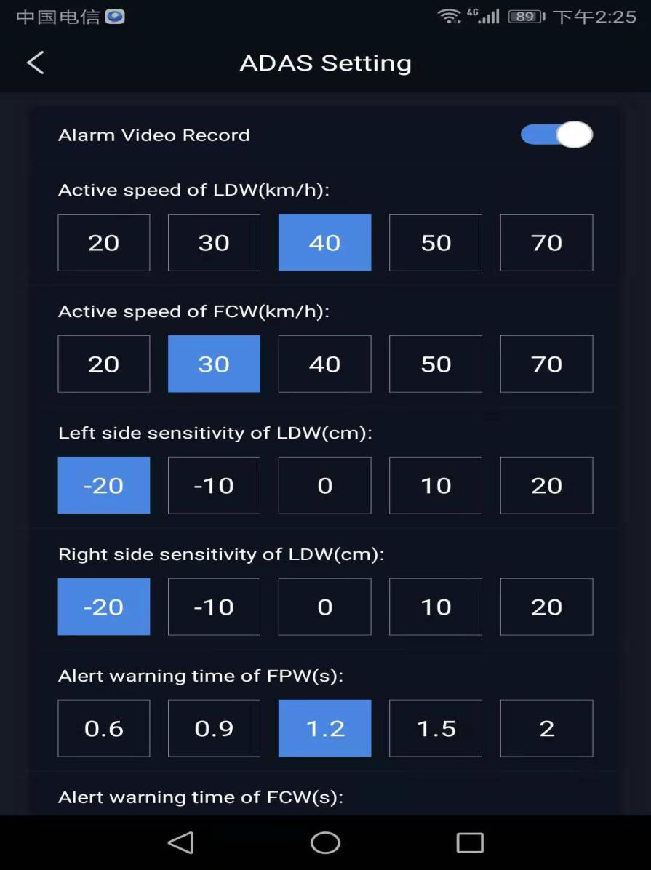

Figure 3.3.2—2

1. ADAS adjustment operation: enter “setting”---ADAS adjustment, refer to picture below, check ADAS video, then adjust scale of camera,input corresponding parameter, to make sure video can cover whole roadside , the boundary line should be same as horizontal line(half for sky, half for roadside)

Note: 1. Adjust the position of the ADAS camera to achieve the best effect, change the horizon value and make the red dashed line between two solid lines. It is better to approach the red solid line below.

2. Different modifications of vehicle middle

3. When the cart is installed, adjust the hood line at the bottom.When installing the car, adjust it above the hood line

4. The recognized area of the camera is above the blue dashed line

5.ADAS camera should be installed at the height above the ground by default. For large vehicles, the distance from the camera to the wheel and the distance from the camera to the front of the car should be input at 0--20CM

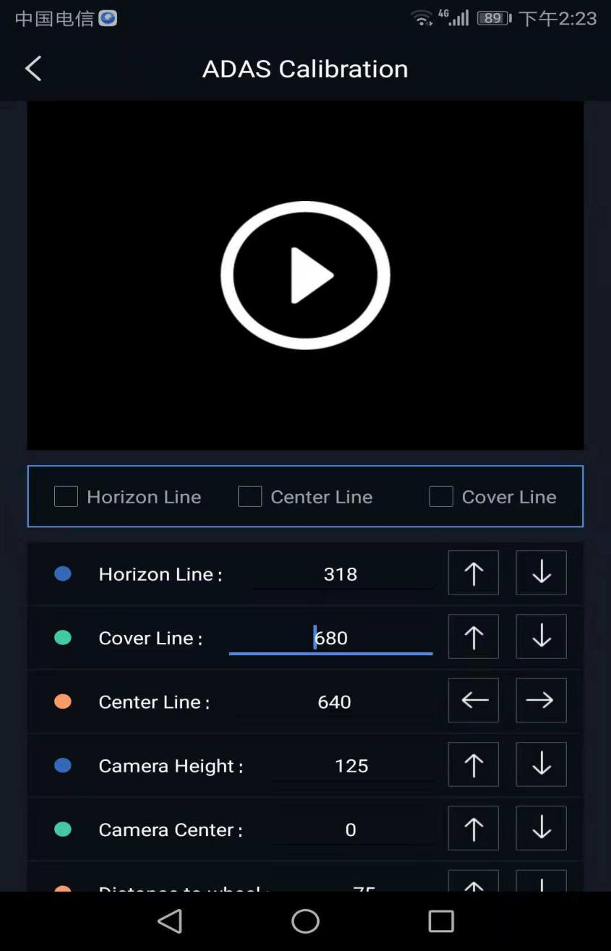

Figure 3.3.2—3

5)If site not be allow,it can mark at same height as ADAS camera location when with distance of 1m from front vehicle, adjust horizontal line to be with same height from APP.

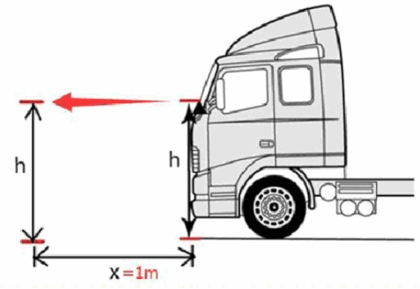

Figure 3.3.2—4

3.4 Identification adjustment

**3.4.1 Registration and driver ID adding**

3.4.1—1 Open debug tool, “configuration”---”ID recognize”,connect it online, click”enable video”, means it can see face image, like following picture.

3.4.1—2 click “site register”, input user ID, align face to red frame, click “face adding”, system will remind add success. Click “register”,then remind register success.

Pls try to align positive face to lens,can save multi people.

It can add user by snapshot or photo of cellphone, click”file register”, --->click”+”for add, select snapshot or picture from album.

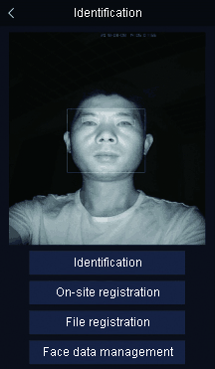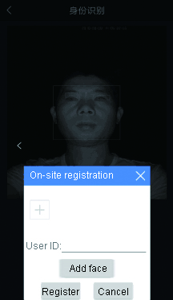

图3.4.1—1 Figure 3.4.1—2

**3.4.2 face recognition test**

Point the face to the camera and click "start recognition" to start the face recognition function of the system. The system will prompt the recognition success and display the user name of the recognition person.In the process of recognition, the face should be as close to the lens as possible. If the side face may lead to prolonged recognition time, the system will prompt the recognition failure or timeout after a certain period of time is not recognized.

**3.4.3 Face library management**

Click”Face library management”to delete user name which already type-in.

3.5 Safety belt adjustment

Safety belt identification and warning, it is necessary to print the image on the basis of the original safety belt, and use special tools to mark the safety belt with special image.

The required tools are: roller tools, special printing oil.The specific operation is as follows:

**Grease the roller tool:**

Open the red cover of the drum tool, pour the special oil into the drum and fill it. Wait for 10-20 minutes after the cover is sealed. After the oil leakage from the drum sponge, roll the drum onto the seat belt.Note: printing can be done from top to bottom or from bottom to top.Print effect is like as below:

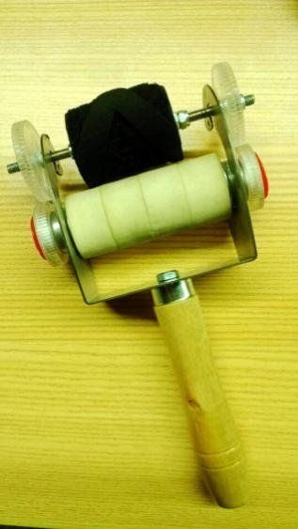 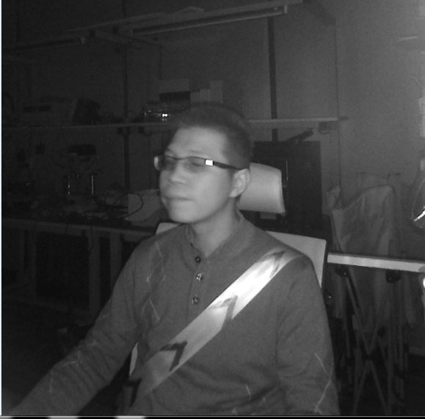

Figure 3.5.1 Figure 3.5.2

4、**[FAQ](D:/Users/win%2010/AppData/Local/Youdao/Dict/8.3.1.0/resultui/html/index.html" \l "/javascript:;)**（**[Frequently](D:/Users/win%2010/AppData/Local/Youdao/Dict/8.3.1.0/resultui/html/index.html" \l "/javascript:;)** **[Asked](D:/Users/win%2010/AppData/Local/Youdao/Dict/8.3.1.0/resultui/html/index.html" \l "/javascript:;)** **[Questions](D:/Users/win%2010/AppData/Local/Youdao/Dict/8.3.1.0/resultui/html/index.html" \l "/javascript:;)**）

**1.Why does it always say "Initialization failed" after I connect to the mobile app?**

1. First, confirm what model is the phone? Some mobile phones do not support OTG function, so can't connect (this can use Baidu query, oppo, vivo, Xiaomi, Huawei, Meizu and other Android phones basically support OTG function, and the OTG function of oppo and vivo mobile phone is off by default, need to be manually opened in the settings);

**B.** After confirming the mobile phone hardware supports the OTG function, it still cannot be connected, and then confirm whether it is necessary to manually open the OTG function in the mobile phone setting option;

**C.**Check if the connection between the ADAS device and the phone is reversed;

**D.**After the APP displays the initialization failure, wait 10 seconds on the home page, the APP home page can normally illuminate the device module status, indicating that the connection has returned to normal (as shown in Figure 1 is the screenshot of new APP home page showing); otherwise, there is no connection, you need to unplug the OTG cable connected to the phone, plug it in again and try it. After plugging in, remember to click the OK button on the phone (Figure 2).

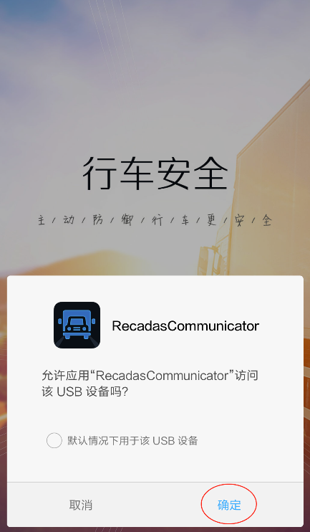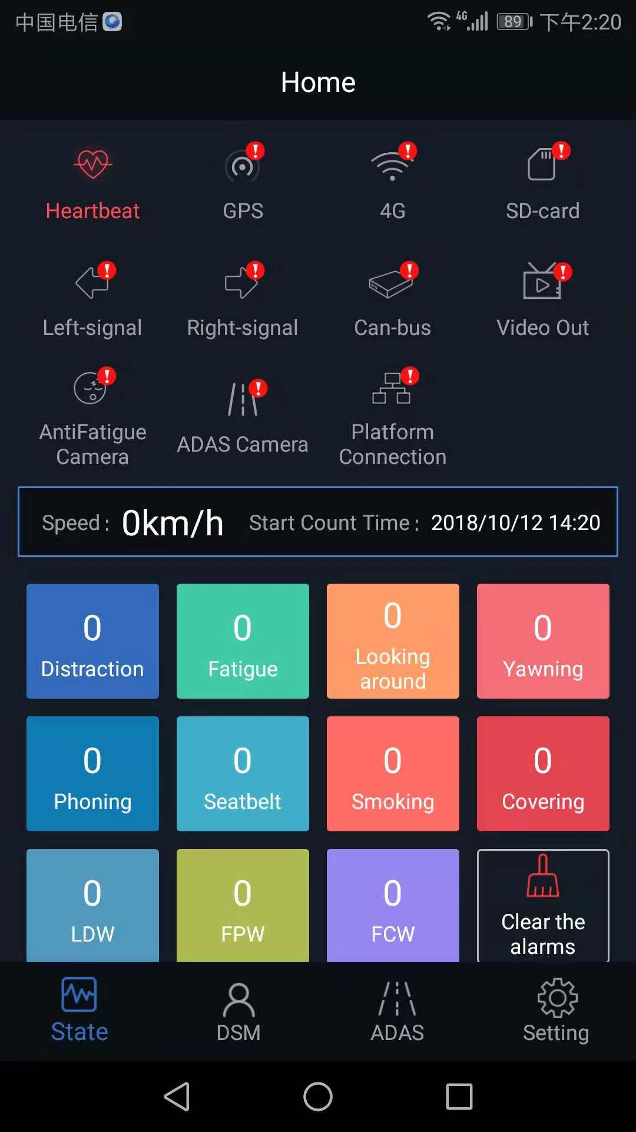

Figure **1**  Figure **2**

**2.Why does it still have no alarms under the static testing after I have connected the device?**

**A.**Confirm the cable on the device is connected correctly.

**B.**Make sure cameras (DSM, ADAS) are powered normally (DSM can view infrared light through appearance to see if it is lit, or you can view it through mobile APP; ADAS can view the status from mobile APP only) as shown in Figure 3, is in a normal state, and gray is an abnormal state;

**C.**Confirm the speed acquired on the device reaches alarm threshold speed (DSM default alarm threshold is 30km/h);

**D.**Confirm the alarm switch on the APP has been turned on (as shown in Figure 4);

**D.**Confirm the test mode is turned on by the APP for testing (as shown in Figure 5 and Figure 6 below) or used a custom driving speed under static environment (greater than the alarm threshold, for example, setting 40km/h).

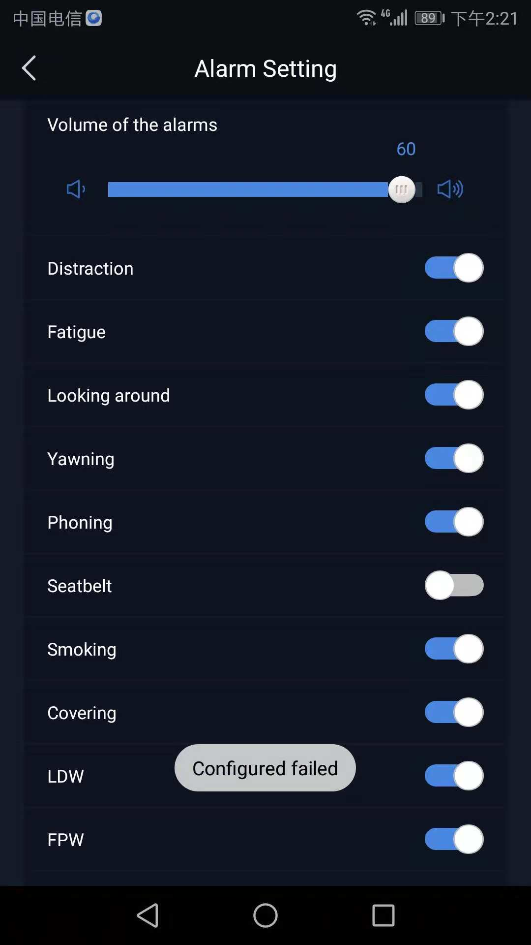

Figure **3** Figure **4**

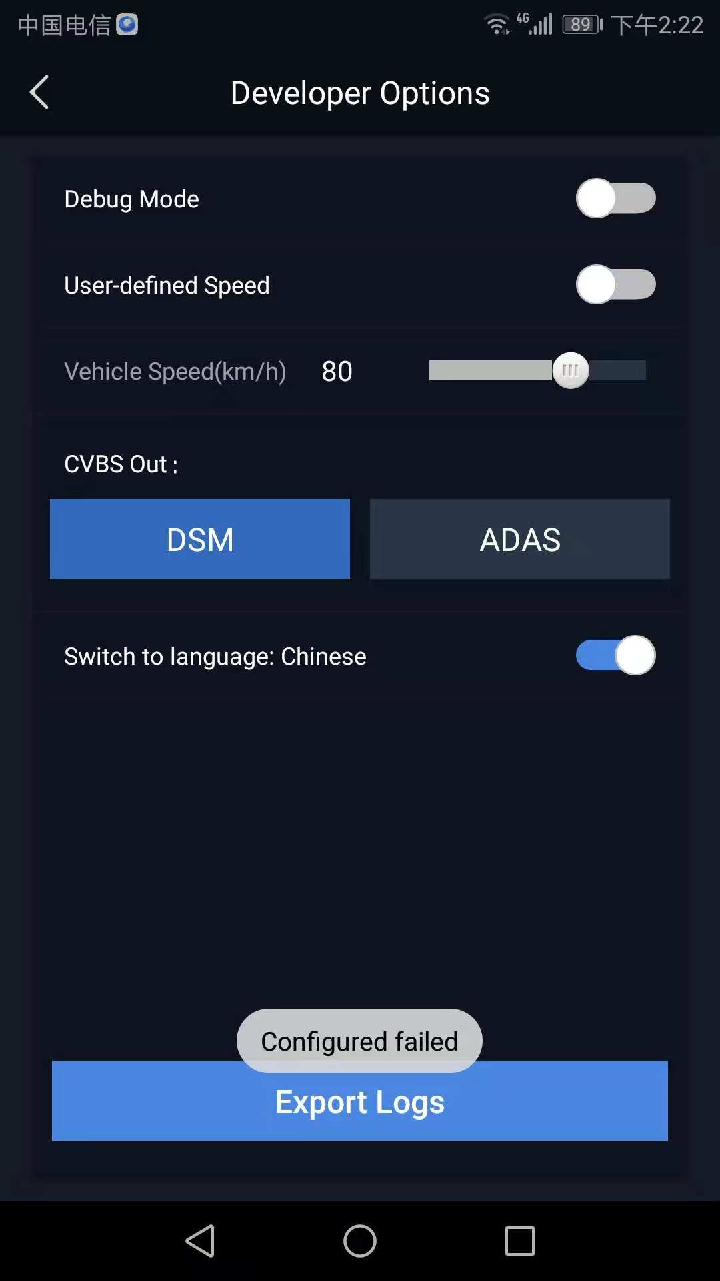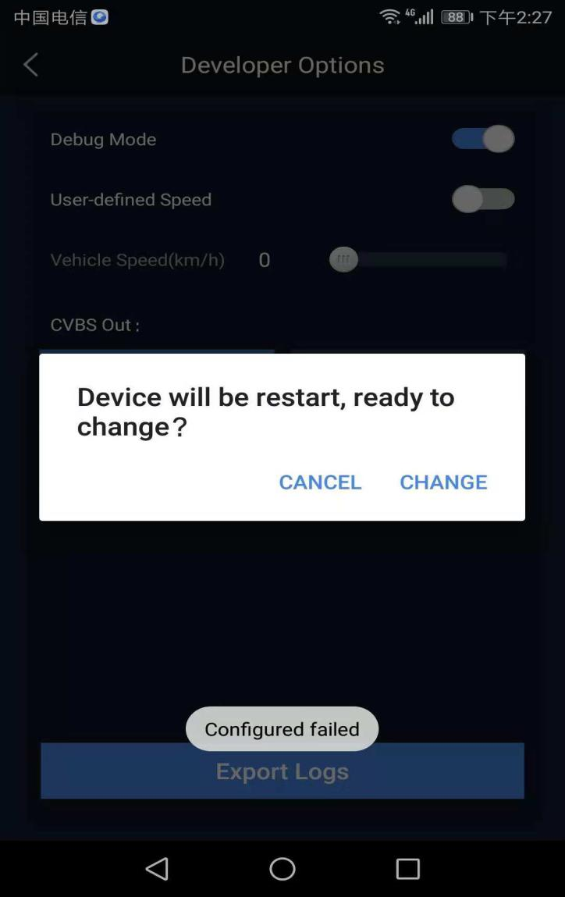

Figure **5**  Figure **6**

**3.Why can't I see the alarm video on the platform?**

**A：**First, confirm the version of the software, the low version does not have this function, you need to upgrade remotely; In addition, the small alarm video is viewed in "Information Management - Statistical Report - Multimedia - Video";

**4.Why do I wear seat belt clearly, but the equipment reports "Please fasten my seat belt"?**

A:The seat belt alarm needs to be recognized by the special ink algorithm of the seat belt brush. Without the seat belt, the alarm is not effective. Even if the seat belt is worn, it will be detected as not wearing the seat belt. The seat belt alarm is turned off default in the later software version, you can manually open it through the mobile phone app if necessary;

**5.**ADAS camera is analog. It does not support hot swap. You must connect the cable before powering on. Otherwise, it will no image. It will be normal after restart the power.

**Note: For more questions, please refer to the FAQ Q&A document.**

5、Appendix

5.1Alarm type

Driver's fatigue and unsafe driving behavior, Lane departure, front vehicle close distance and collision risk will trigger the terminal alarm. The detailed list of terminal alarm conditions is as follows:

|  |  |  |  |
| --- | --- | --- | --- |
| **Alarm type** | **Driving mode** | **Test mode** | **Voice alarm content** |
| **Fatigue level 1** | 2s Driver keeps bowing, blinking, closing eyes for 2s | 2s Driver keeps bowing, blinking, closing eyes for 2s | Please drive carefully |
| **Fatigue level 2** | 5s Driver keeps bowing, blinking, closing eyes for 5s | 5s Driver keeps bowing, blinking, closing eyes for 5s | Please pay attention to danger |
| **Leave driving sight** | Driver look around for 4s, and the state was released after facing the front for 4s. | Driver look around for 4s, and the state was released after facing the front for 4s. | Please pay attention to the road conditions |
| **Yawning** | Driver yawns for 3s reports up to 3 times in 5 minutes. | 2s Driver yawns for 2s | Please pay attention to rest |
| **Calling** | Driver called 7s, released the state after put down the phone for 7s, reports up to 2 times in 5 minutes; | 4s Driver called 4s | Please don't call |
| **Not wearing seat belt** | Driver untied the seat belt for 1 minutes,reported up to 2 times in 5 minutes; | Driver untied the seat belt for 10s | Please fasten your seat belt |
| **Smoking** | Driver smokes more than two cigarettes and reports up to 1 time in 4 minutes. | 3s Driver smokes and reports, 3s | Please don’t smoke |
| **Occlusion camera** | 10s The obstacle blocks the lens completely for 10s | 10s The obstacle blocks the lens completely for 10s | Please don’t block |
| **Equipment failure** | Can't get images for 3s continuously | Can't get images for 3s continuously | Camera failure |
| **Lane departure** | Lane departure | Lane departure | Lane departure |
| **Front car close** | The Front vehicle distance is less than 1.2s (adjustable) multiplied by the current speed | The Front vehicle distance is less than 1.2s (adjustable) multiplied by the current speed | Please keep the distance |
| **Front car collision danger** | Front vehicle distance is less than 0.8s (adjustable) multiplied by the current speed | Front vehicle distance is less than 0.8s (adjustable) multiplied by the current speed | Collision hazard |

**5.2 After installation completed, you need to check the following, checklist**

|  |  |  |
| --- | --- | --- |
| **Check item** | Is the universal joint firm? |  |
| ？Is the camera locked? |  |
| Is the face in the middle of the screen? |  |
| Has the camera protective film been torn off? |  |
| Can it generate an alarm normally? |  |
| Is the ADAS picture normal? |  |
| Does ADAS complete the calibration? |  |
| Is 4G dialing successfully? |  |
| Is the device connected to the server successfully? |  |
| Is there positioning when platform view the device |  |
| Is the platform alarm data normal? |  |
| ？Is there any training for customers?   1. Device installation 2. Equipment debugging 3. Equipment alarm test 4. Platform using method 5. FAQ |  |